Concepts of Operating System

Assignment 1

Problem 1.

a) Navigate and List:

a. Start by navigating to your home directory and list its contents. Then, move into a

directory named "LinuxAssignment" if it exists; otherwise, create it.

Solution-- cd -command is used to move to the home directory.

cd directoryname- command is also used for navigating to a particular directory.

mkdir directoryname -command is used to create a directory .

ls- command is used to list all the files and directory of the current directory.

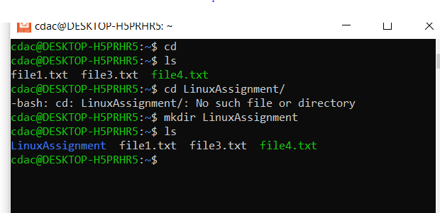

b) File Management:

a. Inside the "LinuxAssignment" directory, create a new file named "file1.txt". Display its

contents.

Solution ---

nano filename- command is used to open a file for editing if its exist, and create and open for editing if doesn’t exist.

cat filename – command is used to display content of a file on console.

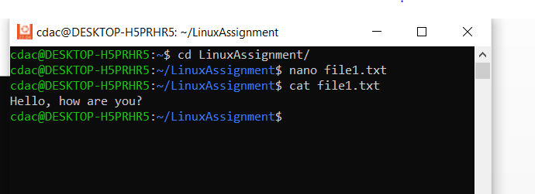

c) Directory Management:

a. Create a new directory named "docs" inside the "LinuxAssignment" directory

Solution---

Navigated to the "LinuxAssignment" directory using cd command.

mkdir directoryname- command is used to create a directory.

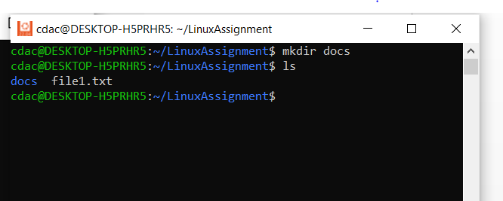

d) Copy and Move Files:

a. Copy the "file1.txt" file into the "docs" directory and rename it to "file2.txt".

Solution—

cp source_path_of_file path_of destination- command is used to copy file from source location to destination

mv file1 file2 – command is used to rename file from file1 to file2

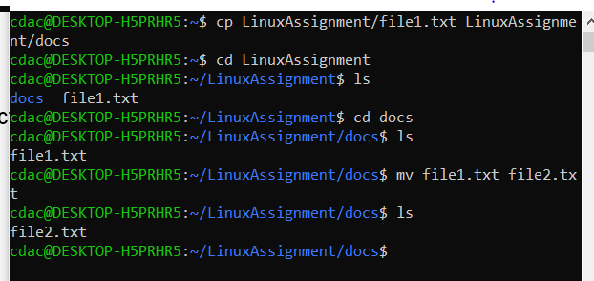

e) Permissions and Ownership:

a. Change the permissions of "file2.txt" to allow read, write, and execute permissions for

the owner and only read permissions for others. Then, change the owner of "file2.txt" to

the current user.

Solution—

chmod command is used to change the permissions of files ,this needs to be given along with the user(u-owner,g-groups,o-others) and permissions to be changed(r-read,w-write,x-execute).

sudo- should be included before chown if the user is not superuser/root user.

sudo chown newowner filename –used to change owner of file

ls –l command is to list files/directories along with additional info such as owner , permissions, etc.

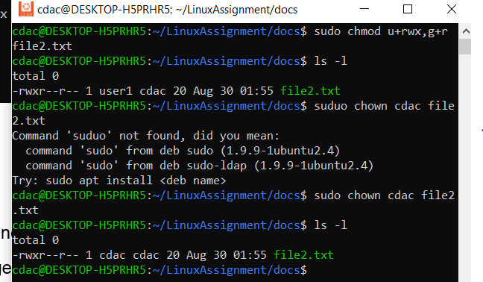

f) Final Checklist:

a. Finally, list the contents of the "LinuxAssignment" directory and the root directory to

ensure that all operations were performed correctly.

Solution—

ls –l command is to list files/directories of current directory along with additional info such as owner , permissions, etc.

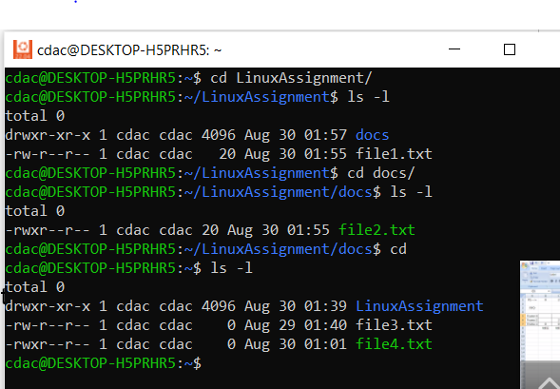

g) File Searching:

a. Search for all files with the extension ".txt" in the current directory and its subdirectories.

Solution—

find directoryname –type f –name “*.extension” command is used to list all the files with the specified extension .

“.”- used for current directory

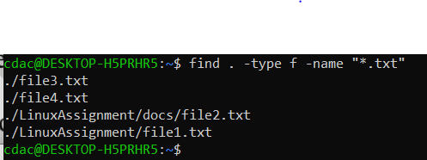

b. Display lines containing a specific word in a file (provide a file name and the specific

word to search).

Solution--

grep pattern filename command searches and list the specified pattern/string in the specified filename.

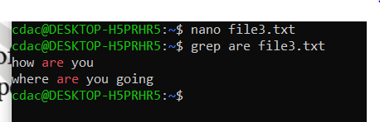

h) System Information:

a. Display the current system date and time

Solution—

date command is used to print the date and time of the system.



i) Networking:

a. Display the IP address of the system.

Solution—

hostname –i (prints the localhost address)

hostname –I(prints the ipv4 address, ipv6 address , temporary ipv6 address)

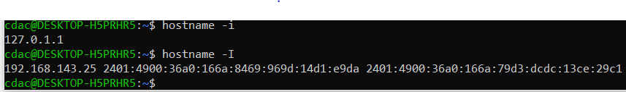

b. Ping a remote server to check connectivity (provide a remote server address to ping).

ping server-command gives the network details of the sepcified server.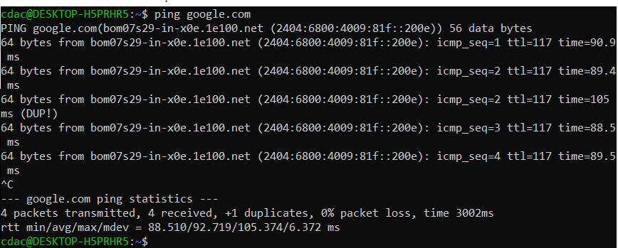

j) File Compression:

a. Compress the "docs" directory into a zip file.

Solution—

zip –r zipfilename directoryname -command creates a zip file of the directory specified.

Needed to install the zip utility through –sudo apt install zip

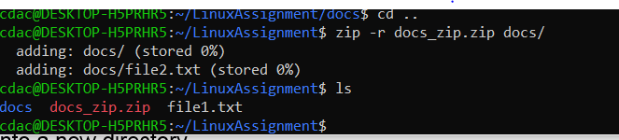

b. Extract the contents of the zip file into a new directory.

Solution—

unzip zipfile_path –d newdirectory command transfers the content of zip file to new directory mentioned.

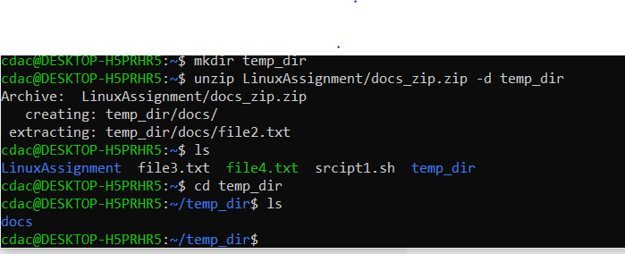

k) File Editing:

a. Open the "file1.txt" file in a text editor and add some text to it.

Solution—

nano filename command creates (if doesn’t exist) and opens it for editing

cat filename command displays the file content.

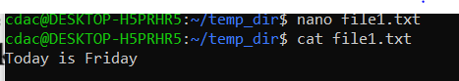

b. Replace a specific word in the "file1.txt" file with another word (provide the original

word and the word to replace it with).

Solution—

sed –i ‘s/substitute/new_word/g’ filename command replaces the substitute word with new_word.

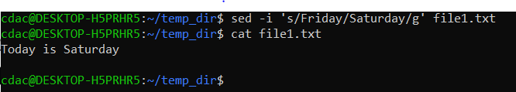

Problem 2:

a. Suppose you have a file named "data.txt" containing important information. Display the

first 10 lines of this file to quickly glance at its contents using a command.

Solution—

head command by default displays the top 10 lines of the file mentioned.

Can also print first ‘n’ lines –> head –n filename.

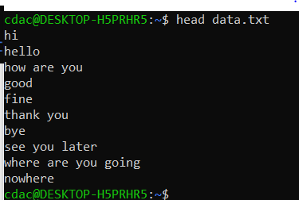

b. Now, to check the end of the file for any recent additions, display the last 5 lines of

"data.txt" using another command.

Solution—

tail -n filename –> prints last n lines of file.By default prints last 10 lines.

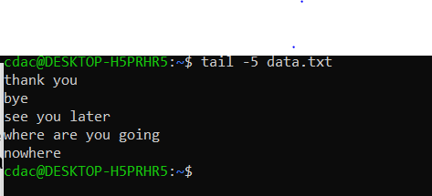

c. In a file named "numbers.txt," there are a series of numbers. Display the first 15 lines of

this file to analyze the initial data set.

Solution—

head –n filename command prints first n lines of file.

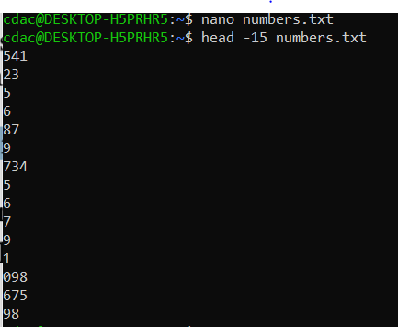

d. To focus on the last few numbers of the dataset, display the last 3 lines of "numbers.txt".

Solution—

tail -n filename –> prints last n lines of file.By default prints last 10 lines

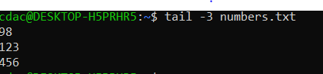

e. Imagine you have a file named "input.txt" with text content. Use a command to translate

all lowercase letters to uppercase in "input.txt" and save the modified text in a new file

named "output.txt."

Solution—

tr a-z A-Z <filename >new file command transforms all lowercase letters to uppercase

‘>’ is a redirection symbol that feeds the new file with eprevious command’s output.

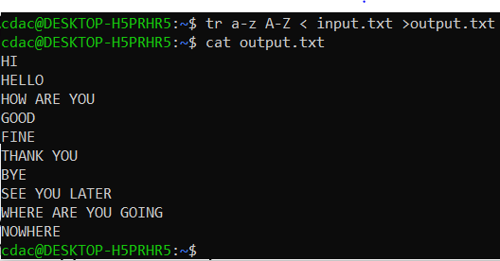

f. In a file named "duplicate.txt," there are several lines of text, some of which are

duplicates. Use a command to display only the unique lines from "duplicate.txt."

Solution—

uniq –u command displays unique lines of a file.This works only when the content is sorted .Hence, sort command is used with it , that sorts the file mentioned.

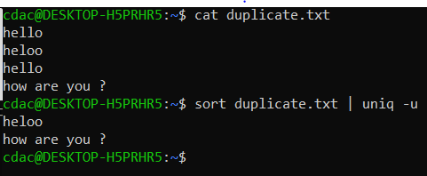

g. In a file named "fruit.txt," there is a list of fruits, but some fruits are repeated. Use a

command to display each unique fruit along with the count of its occurrences in

"fruit.txt."

Solution—

uniq –c command prints all the lines along with its count .It is again used with sort using piping(|).

